Chapter Three: Mathematics of Computer Graphics

Coordinate System
Coordinate system is a method for identifying the location of a point on the earth. Most coordinate systems use two numbers, a coordinate, to identify the location of a point. To specify the location of a point in a 2D or 3D, we need a reference point whose position is already defined. Taking the reference point as the centre or origin, we imagine a set of axes or infinite straight lines, which we call the reference frame. Different conventions in specifying the location of a given point in a reference frame give rise to different coordinate systems. For example, each of these numbers indicates the distance between the point and some fixed reference point, called the origin.

The first number, known as the X value, indicates how far left or right the point is from the origin. The second number, known as the Y value, indicates how far above or below the point is from the origin. The origin has a coordinate of (0,0).

The simplest example of a coordinate system is the identification of points on a line with real numbers using the number line. In this system, an arbitrary point O (the origin) is chosen on a given line. The coordinate of a point P is defined as the signed distance from O to P, where the signed distance is the distance taken as positive or negative depending on which side of the line P lies. Each point is given a unique coordinate and each real number is the coordinate of a unique point.
Figure 3.1: Identification of a point on a line with real number

Rectangular/Cartesian Coordinates
The rectangular coordinate system consists of two real number lines that intersect at a right angle. The horizontal number line is called the x-axis, and the vertical number line is called the y-axis. These two number lines define a flat surface called a plane, and each point on this plane is associated with an ordered pair of real numbers (x, y). The first number is called the x-coordinate, and the second number is called the y-coordinate. The intersection of the two axes is known as the origin, which corresponds to the point (0, 0). The words "Abscissa" and "Ordinate" are just the x and y values. Abscissa is the horizontal ("x") value in a pair of coordinates (i.e. How far along the point is) while Ordinate is the vertical ("y") value in a pair of coordinates (i.e. how far up or down the point is). Figure 3.2 depicts how a rectangular coordinates.

An ordered pair (x, y) represents the position of a point relative to the origin. The x-coordinate represents a position to the right of the origin if it is positive and to the left of the origin if it is negative. The y-coordinate represents a position above the origin if it is positive and below the origin if it is negative. Using this system, every position (point) in the plane is uniquely identified. For example, the pair
(-3, 2) denotes the position relative to the origin as shown in Figure 3.3.

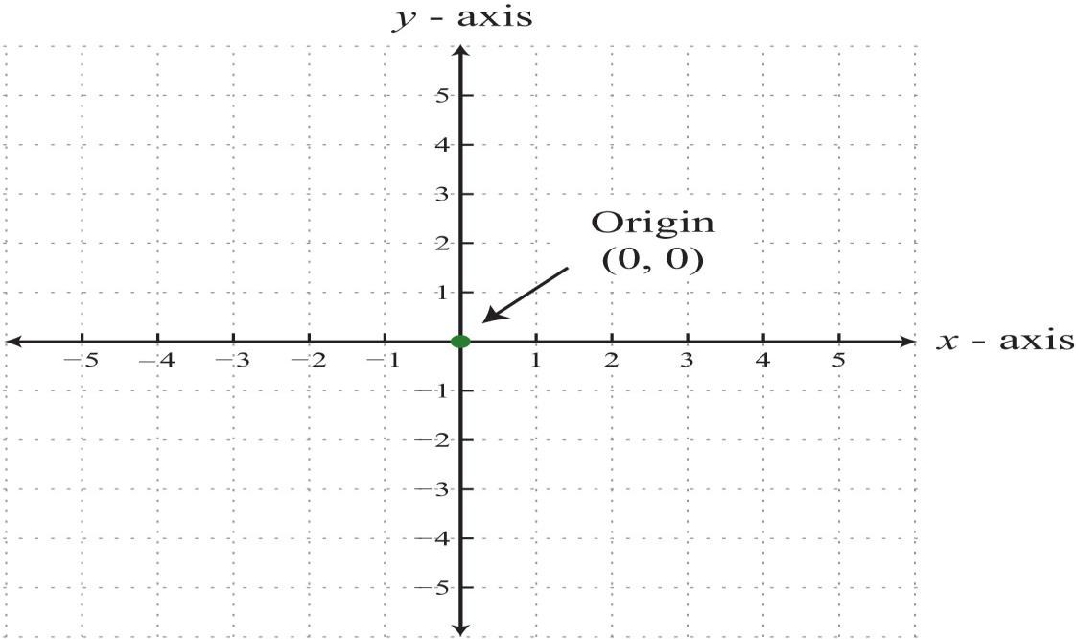
Figure 3.2: Rectangular/Cartesian Coordinate (Origin)

The point is three units to the left and two units up from the origin.
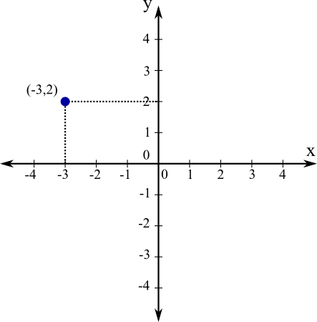
Figure 3.3: Rectangular Coordinate of a point (-3.2)

The x- and y-axes break the plane into four regions called quadrants, named using roman numerals I, II, III, and IV, as pictured. In quadrant I, both coordinates are positive. In quadrant II, the x-coordinate is negative and the y- coordinate is positive. In quadrant III, both coordinates are negative. In quadrant IV, the x-coordinate is positive and the y-coordinate is negative.

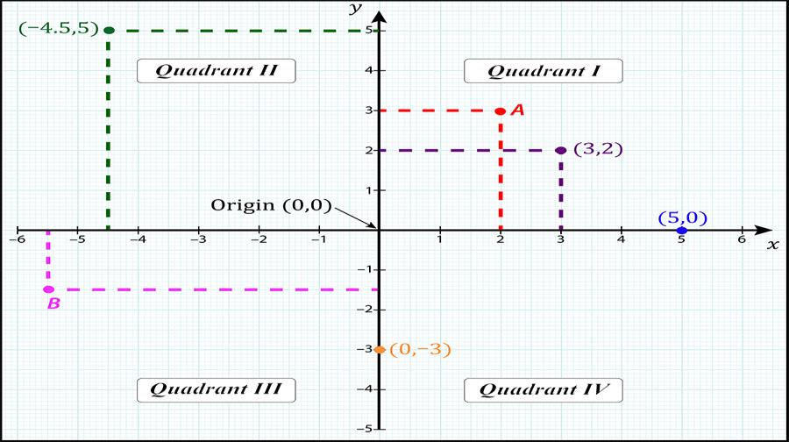
Figure 3.4: The Four Quadrants
Example 1: Plot the ordered pair (−3, 5) and determine the quadrant in which it lies.
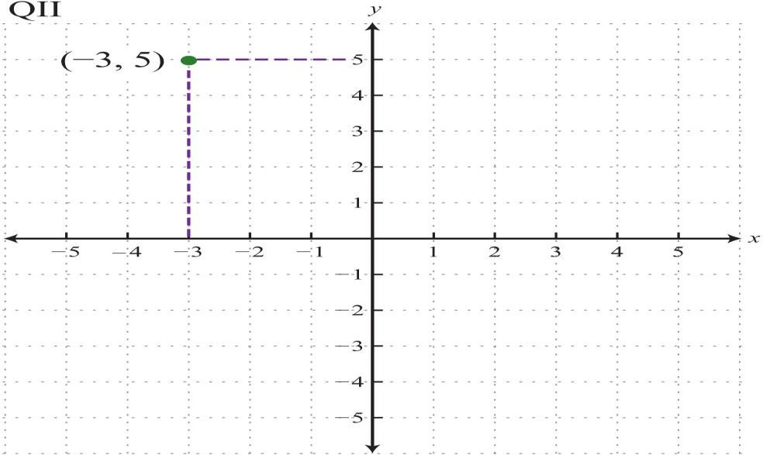
Solution: The coordinates x=−3 and y=5 indicate a point 3 units to the left of and 5 units above the origin.

Example 2: Plot this set of ordered pairs: {(4, 0), (−6, 0), (0, 3), (−2, 6), (−4, −6)}. Solution: Each tick mark on the x-axis represents 2 units and each tick mark on the y-axis represents 3 units.
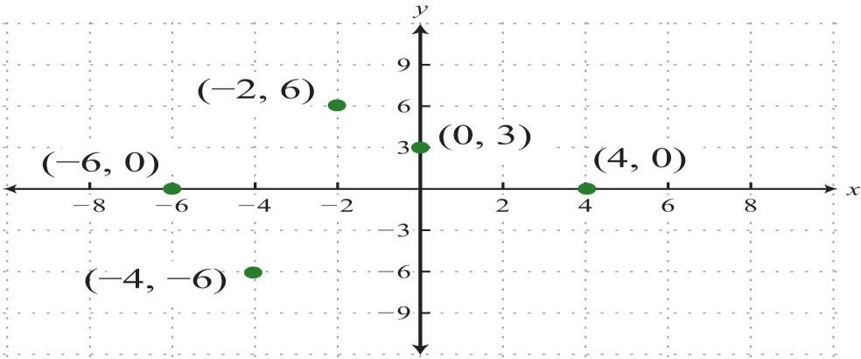

Example 3: Plot this set of ordered pairs: {(−6, −5), (−3, −3), (0, −1), (3, 1), (6, 3)}.

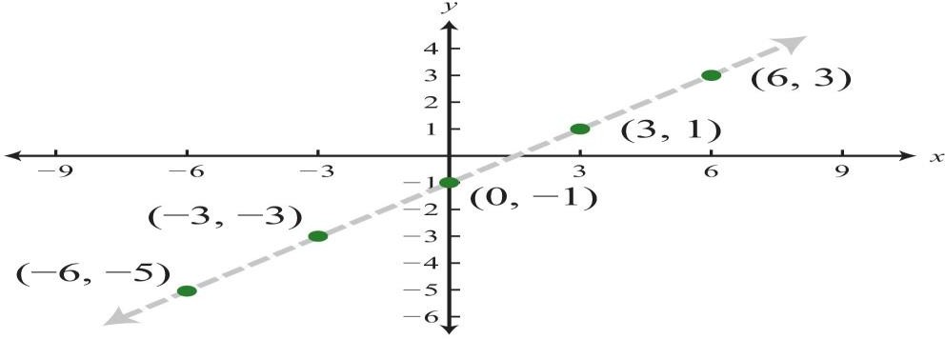
Solution:

Example 4: Plot the set of points {(5, 3), (−3, 2), (−2, −4), (4, −3)} and indicate in
which quadrant they lie.

Solution
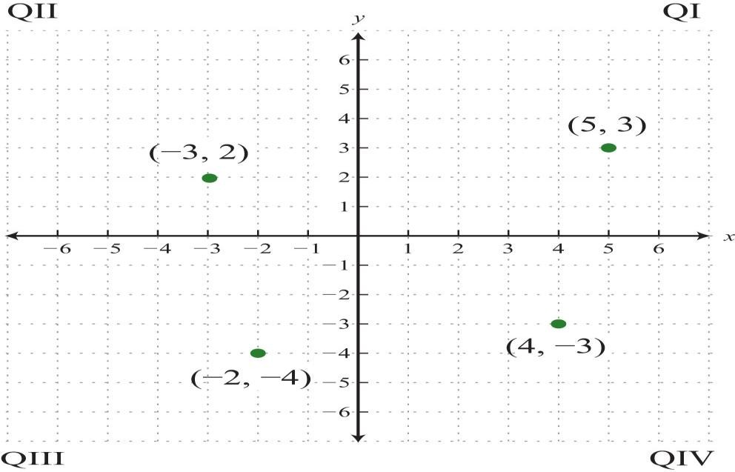

    - Distance Between two points in a Plane
Frequently you need to calculate the distance between two points in a plane. To do this, form a right triangle using the two points as vertices of the triangle and then apply the Pythagorean Theorem. Recall that the Pythagorean Theorem state that “In a right-angled triangle, the square of the hypotenuse side is equal to the sum of squares of the other two sides“. For any given right triangle with two short lengths measuring (x1, y1) and (x1, y1) units, then the square of the measure of the hypotenuse r is equal to the sum of the squares of the lengths of other two short side. That is,
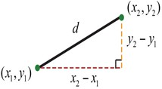

𝒅 = √(𝑥₂ − 𝑥₁)² + (𝑦₂ − 𝑦₁)²

In other words, the hypotenuse of any right triangle is equal to the square root of the sum of the squares of the length of the other sides.

Example 1: Find the distance between (−1, 2) and (3, 5).
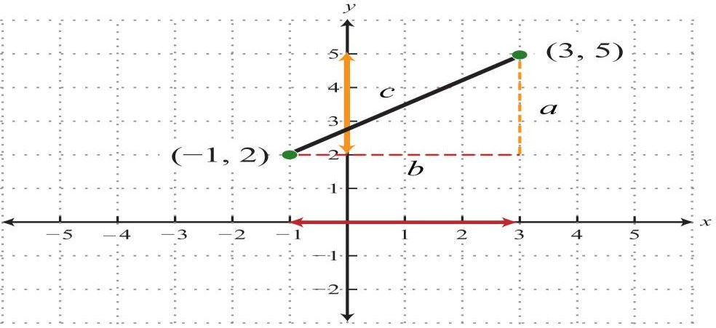
Solution: Form a right triangle by drawing horizontal and vertical lines through the two points. This creates a right triangle as shown below:
x1 = -1, x2 = 3, y1 = 2, y2 = 5

𝒅 = √(𝑥₂ − 𝑥₁)² + (𝑦₂ − 𝑦₁)² = √(3 − (−1))² + (5 − 2)²

= √4² + 3² = √16 + 9 = √25 = 5
Example 2: Calculate the distance between (−3, −1) and (−2, 4).
Solution: Use the distance formula.
(x1, y1) (x2, y2)

(-3, -1) (-2, 4)
𝒅 = √(𝑥₂ − 𝑥₁)² + (𝑦₂ − 𝑦₁)² = √(−2 − (−3))² + (4 − (−1))²

= √(−2 + 3)² + (4 + 1)² = = √(1)² + (5)² = √1 + 25 = √26

Exercise:
Calculate the distance between (−7, 5) and (−1, 13).

Midpoint Formula
The point that bisects the line segment formed by two points, (x1,y1) and (x2,y2), is called the midpoint and is given by the following formula:

𝑥 +𝑥
1 2
𝑚 = (

2
, 𝑦1+𝑦2) 2

The midpoint is an ordered pair formed by finding the average of the x-values
and the average of the y-values of the given points.

Example 1: Calculate the midpoint between (−1, −2) and (7, 4).
Solution: First, calculate the average of the x- and y-values of the given points.
(x1, y1) (x2, y2)
(-1, -2) (7, 4)

−1+7
𝑚 = (

2
, −2+4
2

)= ⁶
2
(

, 2) =(3, 1)

2

The Midpoint is shown on the number line below:
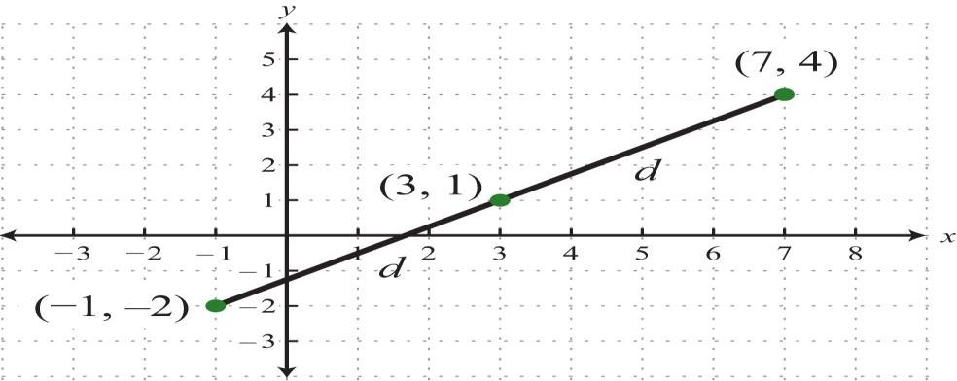

To verify that this is indeed the midpoint, calculate the distance between the two given points and verify that the result is equal to the sum of the two equal distances from the endpoints to this midpoint. This verification is left to the reader as an exercise.

Polar Coordinates
Polar coordinates are a set of values that quantify the location of a point based on the distance between the point and a fixed origin and the angle between the point and a fixed direction. A polar coordinate system is a two-dimensional coordinate system in which each point on a plane is determined by a distance from a reference point and an angle from a reference direction.

Polar coordinates are a complementary system to Cartesian coordinates, which are located by moving across an x-axis and up and down the y-axis in a rectangular fashion. While Cartesian coordinates are written as (x, y), polar coordinates are written as (r, θ). Polar coordinates are points labeled (r, θ) and plotted on a polar grid. The polar grid is represented as a series of concentric circles radiating out from the pole, or the origin of the coordinate plane. The reference point (analogous to the origin of a Cartesian system) is called the pole, and the ray from the pole in the reference direction is the polar axis. The distance from the pole is called the radial coordinate or radius, and the angle is called the angular coordinate, polar angle, or azimuth. The radial coordinate is often denoted by r or ρ, and the angular coordinate by ϕ, θ, or t.
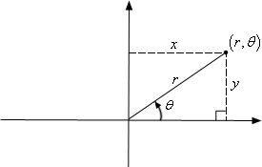
Figure 3.5: Polar Coordinates

The polar grid is scaled as the unit circle with the positive x–axis now viewed as the polar axis and the origin as the pole. The first coordinate r is the radius or length of the directed line segment from the pole. The angle θ, measured in radians, indicates the direction of r. We move counterclockwise from the polar axis by an angle of θ, and measure a directed line segment, the length of r in the direction of θ. Even though we measure θ first and then r, the polar point is

written with the r-coordinate first. For example, to plot the point
(2,
^{𝜋}), we would
4

move ^{𝜋}
)
(
4
units in the counterclockwise direction and then a length of 2 from the

pole. This point is plotted on the grid in Figure 3.6.
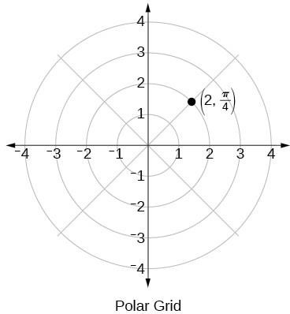

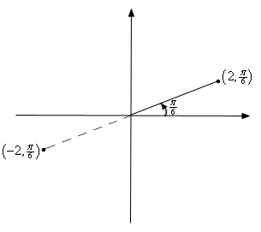
Figure 3.6: Plotting Polar Coordinates For example, below is a sketch of the two points

(2,

𝜋) 6

and

(−2,

^{𝜋}). 6

Conversion from Cartesian Coordinates to Polar Coordinates
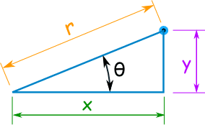
When we know a point in Cartesian Coordinates (x, y) and we want it in Polar Coordinates (r,θ), we solve a right triangle with two known sides.. With this conversion, however, we need to be aware that a set of rectangular coordinates will yield more than one polar point. Converting from rectangular coordinates to polar coordinates requires the use of one or more of the relationships illustrated below. Consider the diagram below.
Recall:

𝑐𝑜𝑠𝜃 = 𝑥
𝑟
𝑠𝑖𝑛𝜃 = 𝑦
𝑟
⟹ 𝑥 = 𝑟𝑐𝑜𝑠𝜃
⟹ 𝑦 = 𝑟𝑠𝑖𝑛𝜃

𝑟² = 𝑥² + 𝑦² ⟹ 𝑟 = √𝑥² + 𝑦²

𝑡𝑎𝑛 𝜃 = 𝑦
𝑥
⟹ 𝜃 = tan⁻¹ 𝑦
𝑥

Example 1: Convert (12,5) in Polar Coordinates.
Solution
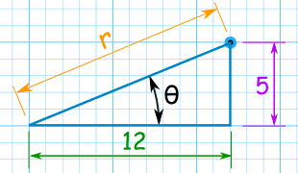
r2 = 122 + 52
r = √ (122 + 52)
r = √ (144 + 25)
r = √ (169) = 13
Use the Tangent Function to find the angle:
tan(θ) = 5 / 12
θ = tan-1 (5 / 12 ) = 22.6° (to one decimal) The point (12,5) is (13, 22.6°) in Polar Coordinates.
When converting from Cartesian to Polar coordinates, the calculator can give the wrong value of tan-1(θ). It all depends what Quadrant the point is located. The table below can be used to adjust the value of tan-1(θ).

Quadrant | Value of tan-1(θ) | X  (horizontal) | Y  (vertical) | Example
I | Use the calculator value | Positive | Positive | (3.4)
II | Add 180° to the calculator value | Negative | Positive | (-5, 8)
III | Add 180° to the calculator value | Negative | Negative | (-2. 1)
IV | Add 360° to the calculator value | Positive | Negative | (5, -6)

Example 2: Convert P = (−3, 10) from Cartesian coordinate to Polar Coordinate

Solution
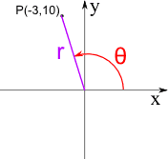
P is in Quadrant II
r=√((−3)2+102)
r = √109 = 10.4 to 1 decimal place
θ=tan-1(10/−3) θ = tan-1(−3.33)
The calculator value for tan-1(−3.33...) is −73.3°
The rule for Quadrant II is: Add 180° to the calculator value
θ = −73.3° + 180° = 106.7°
Therefore, the Polar Coordinates for the point (−3, 10) are (10.4, 106.7°)

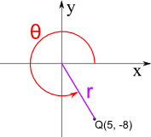
Example 3: Convert Q = (5, −8) from Cartesian coordinate to Polar Coordinate Q is in Quadrant IV

r=√(52+(−8)2)
r = √89 = 9.4 to 1 decimal place
θ=tan-1(−8/5) θ = tan-1(−1.6)
The calculator value for tan-1(−1.6) is −58.0°

The rule for Quadrant IV is: Add 360° to the calculator value
θ = −58.0° + 360° = 302.0°
Therefore, the Polar Coordinates for the point (5, −8) are (9.4, 302.0°)

Conversion from Polar Coordinates to Cartesian Coordinates
When given a set of polar coordinates, we may need to convert them to rectangular coordinates. To do so, we can recall the relationships that exist among the variables x, y, r, and θ, from the definitions of cosθ and sinθ.
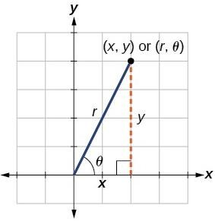
Solving for the variables x and y yields the following formulas:

𝑐𝑜𝑠𝜃 = 𝑥
𝑟
𝑠𝑖𝑛𝜃 = 𝑦
𝑟
⟹ 𝑥 = 𝑟𝑐𝑜𝑠𝜃
⟹ 𝑦 = 𝑟𝑠𝑖𝑛𝜃

Example 1: What is (13, 22.6°) in Cartesian Coordinates? Solution
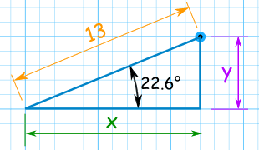

Use the Cosine Function for x: cos( 22.6° ) = x / 13 Rearranging and solving: x = 13 × cos( 22.6° )
x = 13 × 0.923
x = 12.002 ≅ 12

Use the Sine Function for y: sin( 22.6° ) = y / 13 Rearranging and solving: y = 13 × sin( 22.6° )
y = 13 × 0.391
y = 4.996 ≅ 5
Answer: the point (13, 22.6°) is almost exactly (12, 5) in Cartesian Coordinates.

Example 2: What is (12, 195°) in Cartesian coordinates? Solution
r = 12 and θ = 195° x=12×cos(195°) x=12×−0.9659
x = −11.59 to 2 decimal places y =12×sin(195°)
y=12×−0.2588, y = −3.11 to 2 decimal places So the point is at (−11.59, −3.11), which is in Quadrant III

Example 3: Write the polar coordinates (𝟑,
Solution
𝝅) as rectangular coordinates.
𝟐

x = rcosθ = 3cos^{𝝅} = 0
𝟐
y = rsinθ = -3sin^{𝝅} = 𝟑
𝟐
The rectangular coordinates are (0,3).
Example 4: Convert (−𝟒, 𝟐𝝅) into Cartesian coordinates.
𝟑
Solution
x = rcosθ = -4cos^{𝟐𝝅} = -4cos(−𝟏) = 2

y = rsinθ = -4sin^{𝟐𝝅}
𝟑
𝟑
= −𝟒(
√𝟑)
𝟐
𝟐
= -2√𝟑

Therefore in Cartesian coordinates, this point is (2,−2√ 3 ).

Converting equations from one Coordinate system to the other.
We can also convert equations from one coordinate system to the other.
Example 1: Convert the equation 2x−5x3 =1+ xy into polar coordinates.

Solution
What to do to solve this problem is to plug in the formulas for x and y (i.e. the Cartesian coordinates) in terms of r and θ (i.e. the polar coordinates).
Recall that

𝑐𝑜𝑠𝜃 = 𝑥
𝑟
𝑠𝑖𝑛𝜃 = 𝑦
𝑟
⟹ 𝑥 = 𝑟𝑐𝑜𝑠𝜃
⟹ 𝑦 = 𝑟𝑠𝑖𝑛𝜃

2x−5x3 =1+xy = 2(rcosθ) − 5(rcosθ)3 = 1 + (rcosθ)(rsinθ)
= 2rcosθ−5r3cos3θ=1+ r2cosθsinθ

Example 2: Convert r =−8cosθ into Cartesian coordinates.

Solution
r =−8cosθ
Multiply both sides by r
r χ r =−8cosθ х r
r2 = -8rcosθ
But 𝑟² = 𝑥² + 𝑦² and x = rcosθ
Then,
𝑥² + 𝑦² = −8𝑥 = 𝑥² + 8𝑥 + 𝑦²

Vectors
A Vector is an object that has both a magnitude and a direction. A vector is represented by a directed line segment (arrow) which has distinct initial and terminal point. Geometrically, we can picture a vector as a directed line segment, whose length is the magnitude of the vector and with an arrow indicating the direction. The direction of the vector is from its tail to its head.

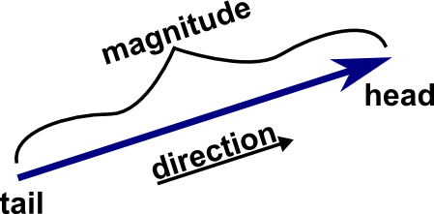
We denote vectors using boldface as in a , b or V. A vector can also be written as the letters of its head and tail with an arrow above it.
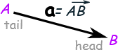

A vector’s length/magnitude of a vector is denoted |a|, ||a|| or |⃗𝑨⃗⃗⃗⃗𝑩⃗⃗⃗⃗→|. We can use the Pythagoras theorem to compute the magnitude of a vector.
|a| = √( x2 + y2 )

For example, the magnitude of the vector b = (6, 8) is computed as follows:
|b| = √( 62 + 82) = √( 36+64) = √100 = 10
The magnitude of the vector w = (1, −2, 3) is:
|w| = √( 12 + (−2)2 + 32 ) = √( 1+4+9) = √14

A vector with length/magnitude of 1 is called a Unit Vector. Multiplication of a vector with a unit vector along the vector direction gives rise to the vector itself.

The zero/null vector is the vector of zero length/magnitude and is denoted by
0. The direction of the zero vector is undefined (no direction is associated with it).

Two vectors A and B having the same magnitude and the same (or parallel) direction are said to be equal and is denoted as A = B
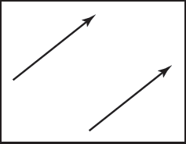

A vector whose magnitude is equal to that of V, but whose direction is opposite to that of V is called the negative of V and is denoted by –V. Thus,
𝑨⃗⃗⃗⃗𝑩⃗⃗→ = −⃗⃗⃗⃗𝑨⃗⃗⃗⃗𝑩⃗⃗→
Vectors can be used to represent many different things. For example, they can be used to store an offset, also called a displacement. If we know “the treasure is buried two paces east and three paces north of the secret meeting place,” then we know the offset, but we do not know where to start. Vectors can also be used to store a location, another word for position or point. Locations can be represented as a displacement from another location. Usually, there is a location that is refer to as the origin from which all other locations are stored as offsets. Note that locations are not vectors. Adding two offsets does make sense, so that is one reason why offsets are vectors. However, this emphasizes that a location is not an offset; it is an offset from a specific origin location. The offset by itself is not the location.

Vector Operations
Vectors have most of the usual arithmetic operations that we associate with real numbers. Two vectors are equal if and only if they have the same length and direction.

Addition of Vectors
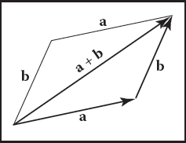
Two vectors are added according to the parallelogram rule. This rule states that the sum/resultant of two vectors is found by placing the tail of either vector against the head of the other. The sum vector is the vector that “completes the triangle” started by the two vectors.

The parallelogram is formed by taking the sum in either order.
c= a + b

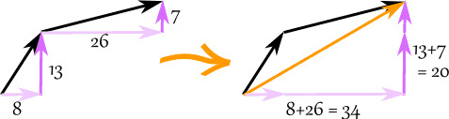
We can then add vectors by adding the x parts and adding the y parts:

The vector (8, 13) and the vector (26, 7) add up to the vector (34, 20)

Addition of vectors satisfies two important properties.
      - The commutative law, which states the order of addition doesn't matter:
a + b = b + a.

This law is also called the parallelogram law, as illustrated in the below image. Two of the edges of the parallelogram define a + b, and the other pair of edges define b + a
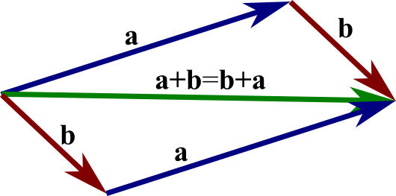

      - The associative law, which states that the sum of three vectors does not depend on which pair of vectors is added first:
(a + b) + c= a + (b + c).

Example 1: add the vectors a = (8, 13) and b = (26, 7)
c = a + b
c = (8, 13) + (26, 7) = (8+26, 13+7) = (34, 20)

Example 2: add the vectors a = (3, 7, 4) and b = (2, 9, 11)
c = a + b
c = (3, 7, 4) + (2, 9, 11) = (3+2, 7+9, 4+11) = (5, 16, 15)

Vector Subtraction
Before we define subtraction, we define the vector - a, which is the opposite of a. The vector - a is the vector with the same magnitude as a but that is pointed in the opposite direction.
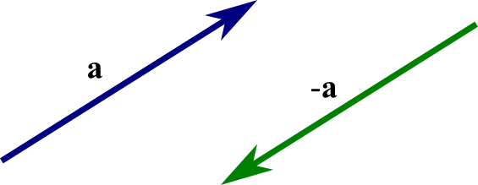
The subtraction of a Vector b from a is taken to be the addition of –a to b and it is written as:
b + (-a) = b - a

Example 1: subtract k = (4, 5) from v = (12, 2) a = v + −k
a = (12, 2) + −(4, 5) = (12, 2) + (−4, −5) = (12−4, 2−5) = (8, −3)

Example 2: subtract (1, 2, 3, 4) from (3, 3, 3, 3)
(3, 3, 3, 3) + − (1, 2, 3, 4)
= (3, 3, 3, 3) + (−1,−2,−3,−4)
= (3−1, 3−2, 3−3, 3−4)
= (2, 1, 0, −1)

Scalar Multiplication
When we multiply a vector by a scalar, it is called "scaling" a vector, because we change how big or small the vector is. In general, the product λA of a vector A and a scalar λ is a vector whose magnitude is λ times that of A and the direction is same or opposite to that of A according to λ being positive or negative. If λ is positive, then λA is the vector whose direction is the same as the direction of A and whose length is λ times the length of A. If λ is negative, then λA is the vector whose direction is the opposite as the direction of A and whose length is λ times the length of A. In this case, multiplication by λ simply stretches (if λ > 1) or compresses (if 0 < λ < 1) the vector A.

Scalar multiplications satisfies many of the same properties as the usual multiplication.
- λ(A+B) = λA+ λB  - (s+t)A =sA+tA  - 1A = A | (s and t are scalar) | (distributive law, form 1) (distributive law, form 2)
4. (−1)A =-A
5. 0A = 0

Example 1: Multiply the vector m = (7, 3) by the scalar 3
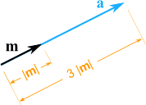
a = 3m = (3 × 7, 3 × 3) = (21, 9)
It still points in the same direction, but is 3 times longer

Centroid or Mean Centre
The concept of centroid is the multivariate equivalent of the mean. Just like the mean, the centroid of a cloud of points minimizes the sum of the squared distances from the points of the cloud to a point in the space. The centroid of a set of vectors is also called the center of gravity, the center of mass, or the barycenter of this set.

Let there be n points A, B, C in space whose position vectors are A, B, C respectively relative to an origin 0. Then the centroid or mean centre of those points G given by the position vector.

𝑂⃗⃗⃗𝐺⃗⃗→ = 1
𝑁
(𝐴 + 𝐵 + 𝐶 + ⋯ )

Thus, the centroid of a triangle whose vertices are (x1, y1, z1), (x2, y2, z2) and (x3, y3, z3) is:
[𝑥1+𝑥2+𝑥3 , 𝑦1+𝑦2+𝑦3 , 𝑧1+𝑧2+𝑧3 ]

3 3 3

Dot Product
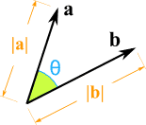
The simplest way to multiply two vectors is the dot product. The dot product of two vectors a and b is denoted a· b and is often called the scalar product because it returns a scalar. The dot product returns a value related to its arguments’ lengths and the angle φ between them.

The simplest way to multiply two vectors is the dot product. The dot product of two vectors a and b is denoted a· b and is often called the scalar product because it returns a scalar. The dot product returns a value related to its arguments’ lengths and the angle φ between them.
It is calculated as:

a · b = |a| × |b| × cos(θ)
Where:
|a|is the magnitude (length) of vector a
|b| is the magnitude (length) of vector b
θ is the angle between a and b.

The dot product is positive or negative according as θ is acute or obtuse. The magnitude of the angle between vectors A and B is 𝜃 = tan−1 𝐴.𝐵
|𝐴||𝐵|
We can also calculate it this way:
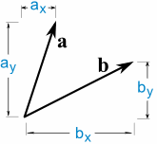
a · b = ax × bx + ay × by

The most common use of the dot product in graphics programs is to compute the cosine of the angle between two vectors. The dot product can also be used to find the projection of one vector onto another. This is the length a→b of a vector a that is projected at right angles onto a vector b.
𝒂.𝒃

a→b = cosθ =

||𝒃||

The dot product obeys the familiar associative and distributive properties we have in real arithmetic:
a · b = b · a,
a · (b + c) = a · b + a · c, (ka) · b = a · (kb) = ka · b. a · b = |a| × |b| × cos(θ)
Where:
|a|is the magnitude (length) of vector a
|b| is the magnitude (length) of vector b
θ is the angle between a and b

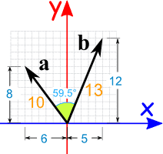
Example 1: Calculate the dot product of vectors a and b:
a · b = |a| × |b| × cos(θ)
a · b = 10 × 13 × cos(59.5°)
a · b = 10 × 13 × 0.5075...
a · b = 65.98 = 66 (rounded)

OR we can calculate it this way:
a · b = ax × bx + ay × by a · b = -6 × 5 + 8 × 12 a · b = -30 + 96
a · b = 66

Both methods came up with the same result (after rounding). Also, note that we used minus 6 for ax (it is heading in the negative x-direction).

Example 2: calculate the Dot Product for:

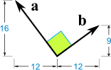
a · b = |a| × |b| × cos(θ)
a · b = |a| × |b| × cos(90°)
a · b = |a| × |b| × 0
a · b = 0
or we can calculate it this way:
a · b = ax × bx + ay × by
a · b = -12 × 12 + 16 × 9
a · b = -144 + 144
a · b = 0

Cross Product
The cross product a × b is usually used only for three-dimensional vectors.
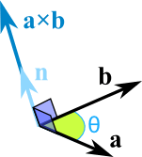

The cross product returns a 3D vector that is perpendicular to the two arguments of the cross product. The length of the resulting vector is related to sinθ:
a × b = |a| |b| sin(θ) n

Where

|a| is the magnitude (length) of vector a
|b| is the magnitude (length) of vector b
θ is the angle between a and b
n is the unit vector at right angles to both a and b

The magnitude |a×b| is equal to the area of the parallelogram formed by vectors
a and b. In addition, a × b is perpendicular to both a and b. It can calculated this way also:

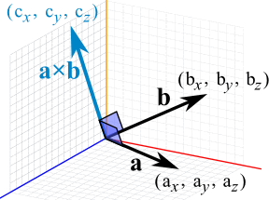

When a and b start at the origin point (0,0,0), the Cross Product will end at:
cx = aybz − azby cy = axbz - azbx cz = axby − aybx

The cross product could point in the opposite direction and still be at right angles to the two other vectors, so we have the: "Right Hand Rule"
With your right-hand, point your index finger along vector a, and point your middle finger along vector b: the cross product goes in the direction of your thumb.
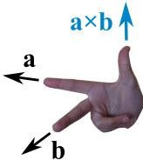

Example: The cross product of a = (2,3,4) and b = (5,6,7)
cx = aybz − azby = 3×7 − 4×6 = −3 cy = axbz - azbx = 2×7 - 4×5 = -6 cz = axby − aybx = 2×6 − 3×5 = −3 a × b = (−3,-6,−3)

Matrices
A series of points, each of which is a position vector relative to some coordinate system is stored in a computer as a matrix or array of numbers representing graphics objects. Such matrices need to be manipulated to change the position of the points, for it may be desirable to scale, rotate, translate, distort, or develop isometric or perspective view of the object while visualizing it. In Computer graphics, all such transformation or more specifically, geometric and viewing transformation are accomplished using matrices. Matrices has become universal tools of graphics programs that are used to change or transform points and vectors.

A matrix is a rectangular array of quantities (numbers, functions, or numerical expression) which are called elements of the matrix. Some example are:

4.75 0 −3.00 𝑒^{𝑥} 𝑥 𝑥

[
8.57 −0.02 1.65
] , [
𝑒
2𝑥
₂] , [𝑙 𝑚 𝑛], [𝑦]
𝑧
𝑥

Matrices are identified according to the number of rows and columns. For instance, the second matrix is 2 by 3 matrix.

In general, we can write an m by n matrix A as:
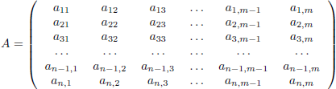
Where m = Number of rows, n = Number of Columns, m χ n = Number of elements.

The rows and columns of a matrix determines the dimension of a matrix. A matrix containing 2 rows and 3 columns is of dimension 2x3. Dimensions in matrix arithmetic is very important, since some operations are not possible unless matrices have identical dimensions. The order or the size of the rectangular matrix A is m by n.

The elements of the matrix are denoted by a letter followed by two subscript, which specify the row and column. aij is the element in the ith row and jth column.

A matrix should be treated as a single entity with a number of components rather than a collection of numbers. For example, the direction cosines of a unit vector or coordinates of a point may be may be represented in a matrix form as [l,m.n] or [x, y, z] respectively. Unlike determinant, a matrix cannot be reduced to a single number and the question of finding the value of a matrix never arises.

Determinants
For every square matrix, a specific number or value is assigned and it is called the determinant. It is an integer value obtained through a range of methods using the elements of the matrix. The determinant can be viewed as a function whose input is a square matrix and whose output is a number. Determinants play an important role in finding the inverse of a matrix and in solving systems of linear equations. In calculating the determinant, we assume we have a square matrix (m = n). The determinant of a matrix A will be denoted by det(A) or |A|.

Determinant of a 2×2 matrix
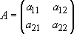
Assuming A is an arbitrary 2×2 matrix A, where the elements are given by:
Then the determinant of the matrix is as follows:

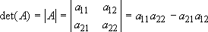

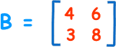
Calculate the determinant of the 2 х 2 matrix given by:
|B|= 4×8 − 6×3
= 32 − 18
= 14

Determinant of a 3×3 matrix
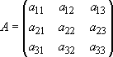
The determinant of a 3×3 matrix is found as follows (assuming A is an arbitrary 3×3 matrix, where the elements are given below).

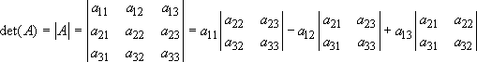
Then the determinant of the matrix is as follows:
|A| = a11 (a22.a33 –a23.a32) – a12 (a21.a33 – a23.a31) + a13 (a21.a22 –
a22.a31)

Example 1: Find the determinant of the 3×3 matrix below.
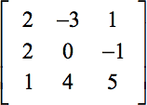
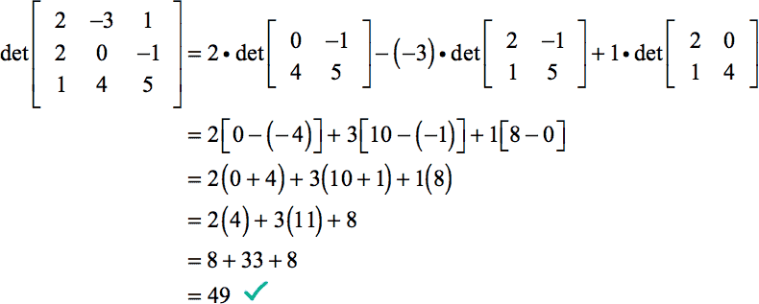

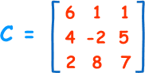
Example 2: Calculate the determinant of the 2 х 2 matrix given by:
|C|= 6×(−2×7 − 5×8) − 1×(4×7 − 5×2) + 1×(4×8 − (−2×2))
= 6×(−54) − 1×(18) + 1×(36)

= −306

Equality of Matrices
Two matrices A and B are said to be equal if A and B have the same order and their corresponding elements be equal. Thus if A = (aij)m,n and B = (bij)m,n then A
= B if and only if aij = bij for i = 1, 2, 3, ....., m; j = 1, 2, 3, , n.

The number of rows in matrix A = The number of rows in matrix B and The number of columns in matrix A = The number of columns in matrix B

Corresponding elements of the matrix A and the matrix B are equal, that is the entries of the matrix A and the matrix B in the same position are equal.
Otherwise, the matrix A and the matrix B are said to be unequal matrix and we
represent A ≠ B.

For example:
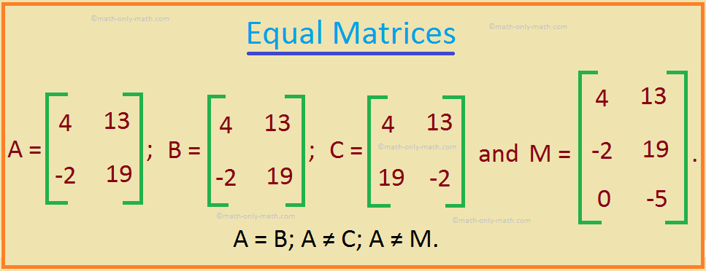

      - A = B because A and B are of the same order, 2 × 2, and corresponding elements are equal. [Here, (1, 1)th element = 4 in both, (1, 2)th element = 13 in both; (2, 1)th element = -2 in both and (2, 2)th element = 19 in both.
      - A ≠ C because corresponding elements are not equal. [Here, (2, 1)th element of A = -2 but (2, 1)th element in C = 19.]
      - A ≠ M because they are not of the same order. [Here, A is a 2 × 2 matrix while M is a 3 × 2 matrix.

Row and Column Matrices
A matrix having single row is called a row matrix. For example, the matrix A = [1 2 4 5] is a row matrix.
A matrix having a single column is called a column. The matrix A below is a
4
column matrix 𝐴 = [ 6 ]
8

Row and column matrix are sometimes called row vectors and column vectors. When various operations are expressed in matrix form, the standard mathematical convention is to represent a vector with a column matrix. Following this convention, we the matrix representation for a three- dimensional
𝑉_{𝑥}
vector V = Vxi + Vyj + Vzk as 𝑉 = [ 𝑉𝑦 ]. As the coordinate of a point in space
𝑉_{𝑧}
represent the components of the position vector of that point P(x, y, z) can also
𝑥
be expressed in column vector form as 𝑃 [ 𝑦]
𝑧

Square Matrix
A Square matrix is a matrix with an equal number of rows and columns. For example, the matrix A below is a square matrix of order 3.
 | 1 | 2 | 3
𝐴 = | [2 | 3 | 4]
 | 3 | 4 | 5
The diagonal of the matrix containing the element 1, 3, 5 is called the leading or principal diagonal.

Rectangular Matrix
A matrix is said to be a rectangular matrix if the number of rows is not equal to the number of columns. For example, matrix A given by:
2 4
𝐴 = [3 6]
5 7
is rectangular Matrix of order 2 × 3.

Diagonal and related Matrices
A Diagonal matrix is a square matrix that has all its elements zero except for those in the diagonal from top left to bottom right (i.e. except those in the leading diagonal of the matrix). For example, Matrix B is a diagonal matrix.
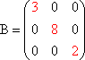

A Scalar matrix is a diagonal matrix where all the diagonal elements are equal. The matrix below is a Scalar matrix. For example, the matrix
3 | 0 | 0
(0 | 3 | 0) | is a Scalar matrix.
0 | 0 | 3
An Upper triangular matrix is a square matrix where all the elements located below the diagonal are zeros. For example, the matrix

2 3 −2
(0 1 4
0 0 5

) is an upper triangular matrix.

A Lower triangular matrix is a square matrix where all the elements located above the diagonal are zeros. For example, the matrix
3 | 0 | 0
(−1 | 4 | 0) is a lower triangular matrix.
2 | 5 | 1

Unit/Identity Matrix
A Unit matrix/Identity matrix is a diagonal matrix whose elements in the principal diagonal are unity (i.e. all ones). A Unit matrix of order n is denoted by In or simply I.
 | 1 | 0 | 0
Thus, 𝐼₃ = | [0 | 1 | 0] is a Unit/Identity matrix.

    - Zero/Null Matrix
0 0 1

A Zero matrix or a Null matrix is a matrix that has all its elements to be zero. It is denoted by O. Thus, 𝑂 = [0 0 0]
2×3
0 0 0

Singular Matrix
A square matrix is said to be singular if its determinant is zero. Otherwise, it is
2 5 19
non-singular. For example, [ 1 −2 −4] is a singular matrix because its

determinant |
2 5 19
1 −2 −4|
−3 2 0
−3 2 0

= 2[(-2 х 0) – (-4 х2)] -5[(1 х 0) – (-4 х -3)] + 19[(1 х 2) –(-2 х -3)
= 16 + 60 – 76 = 0

Symmetric and Skew Symmetric Matrices
A Square matrix A = [aij] is said symmetric when aij = aji for i and j. For example,
𝑎  [𝑏  𝑐 | 𝑏  𝑒  𝑑 | 𝑐  𝑑] is a Symmetric matrix.  𝑓
In other words, a matrix is symmetric if the transpose of Matrix A is equal to
matrix A itself (i.e. AT = A)
1 |  |  | 3 | 8
For example, consider the matrix 𝐴 = [3 |  |  | 8 | −4]. The transpose of matrix A
is |  | 8 | −4 | 6

𝐴𝑇
1 | 3 | 8
= [3  8 | 8  −4 | −4]  6 | . Hence, matrix A is Symmetric

If for a square matrix aij = -aji for all i and j and the principal diagonal elements are zero, then the matrix is called a skew – symmetric matrix. For example,
0 | 𝑎 | 𝑏
[−𝑎 | 0 | 𝑐]
−𝑏 | −𝑐 | 0
In other words, we can say that matrix A is said to be skew-symmetric if
transpose of matrix A is equal to negative of Matrix A(i.e. AT = A). . Matrix B
 | 0 | 6 | 4
below is skew-symmetric matrix (i.e. BT = A). 𝐵 = | [−6 | 0 | 7]

matrix.

𝐵𝑇
−4 −7 0

Addition of Matrices
 | 0 | −6 | −4
= | [6 | 0 | −7]. | Hence, matrix | B is | skew-symmetric
 | 4 | 7 | 0

Two matrices A and B can be added if and only if their dimensions are the same (i.e. both matrices have the same number of rows and columns. Matrix addition is the operation of adding two or more matrices by adding the corresponding entry of each matrix together (i.e. (A + B)[i, j] = A[i, j] + B[i, j] ).
If 𝐴 = [𝑎1 𝑏1 𝑐1] . 𝐵 = [𝑝1 𝑞1 𝑟1]

Then
𝑎2 𝑏2 𝑐2
𝑝2 𝑞2 𝑟2

𝐴 + 𝐵 =
𝑎1 + 𝑝1 𝑏1 + 𝑞1 𝑐1 + 𝑟1 [𝑎2 + 𝑝2 𝑏2 + 𝑞2 𝑐2 + 𝑟2]

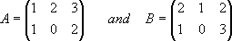
The addition of MatriX A and B below
Is:
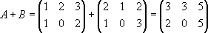

Subtraction of Matrices
Two matrices A and B can be subtracted if and only if their dimensions are the same (i.e. both matrices have the same number of rows and columns). Matrix

subtraction is the operation of subtracting two or more matrices by subtracting the corresponding entry of each matrix together (i.e. (A - B)[i, j] = A[i, j] - B[i, j]).
If 𝐴 = [𝑎1 𝑏1 𝑐1] . 𝐵 = [𝑝1 𝑞1 𝑟1]

Then
𝑎2 𝑏2 𝑐2
𝑝2 𝑞2 𝑟2

𝐴 − 𝐵 =
𝑎1 − 𝑝1 𝑏1 − 𝑞1 𝑐1 − 𝑟1 [𝑎2 − 𝑝2 𝑏2 − 𝑞2 𝑐2 − 𝑟2]

The subtraction of MatriX A and B below
Is:
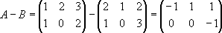

Scalar Multiplication of Matrices
If A be a matrix [aij]mхn and k be a scalar quantity, then the product Ak is the matrix [bij]mхn where bij = kaij .
Hence, 𝑘 × [𝑎1 𝑏1 𝑐1]= [𝑘𝑎1 𝑘𝑏1 𝑘𝑐1 ]
𝑎2 𝑏2 𝑐2 𝑘𝑎2 𝑘𝑏2 𝑘𝑐2
Note: The product of a matrix and a number is a matrix and not a number. The distributive law is true for such products. i.e. k(A + B) = KA + Kb

For example,
5 7 3 6 × 5 6 × 7 6 × 3 30 42 18
2 | 4 | 1 | 6 × 2 | 6 × 4 6 × 1 | 12 | 24 | 6

6 × [
] = [
] = [ ]

Multiplication of Matrices
Two matrices can be multiplied only when the number of columns in the first matrix is equal to the number of rows in the second matrix. If we consider a matrix A of order m х n and a second matrix B of order r х s, then to multiply these two matrices, the value of n must be equal to the value of r and the resulting product matrix AB will be a n х s matrix. Therefore, 2 х 3 matrix multiplied by a 2 х 2 matrix will produce a 2 х 3.

Now during multiplication of two matrices A and B, each element in successive rows of A is multiplied with element of successive columns of B and the results are added to yield a single element of the resulting AB.

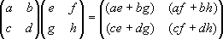
Here is an example of matrix multiplication for two 2×2 matrices.
Here is an example of matrix multiplication for two 3 ×3 matrices.

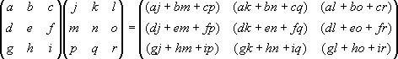

For example,

 | 1 | 4 0 | 3 | 2 | 1 | 7 | 10 13
If | 𝐴 = [2 | 5 0] and 𝐵 = | [1 | 2 | 3], then | 𝐴𝐵 = [11 | 14 17].

3 6 0

Verify the answer.
4 5 6
15 18 21

Notes the followings:
      - Multiplication of matrices is not commutative. That is,
AB ≠ BA
      - Matrix multiplication operation follow distributive law (i.e. is distributive) (A + B)C = AC + BC for all m-by-n matrices A and B and n-by-k matrices C ("right distributive").
C (A + B) = CA + CB for all m-by-n matrices A and B and k-by-m matrices
C ("left distributive").
      - Matrix multiplication is associative: A(BC) = (AB)C
      - Matrix multiplication is the most frequently used operation in Computer Graphics. It can be programmed as a module (i.e. subroutine, function or method) of a graphics package using the formula:
𝑛
𝐴𝐵 = [𝑎_{𝑖𝑗}][𝑏_{𝑖𝑗}] = ∑ 𝑎_{𝑖𝑘} 𝑏_{𝑘𝑗}
𝑘=1

Minor and Cofactor of a Matrix
Consider the Matrix A below:
The Minor of an element in a matrix is defined as the determinant obtained by deleting the row and column in which that element lies. e.g. in the determinant
𝑎11 𝑎12 𝑎13
𝐷 = [𝑎21 𝑎22 𝑎23]
𝑎31 𝑎32 𝑎33

The minor of a

is denoted by 𝑀
𝑎22 𝑎23| and the minor of a

denoted

by 𝑀
11
𝑎21 𝑎23
11 = |𝑎32 𝑎33 12

12 = |𝑎31 𝑎33|
The Cofactor of an element aij is related to its minor as 𝐶_{𝐼𝐽} = (−1)^{𝐼+𝐽}𝑀_{𝐼𝐽}, where
i denotes ith row and j denotes the jth column to which the element 𝑎𝑖𝑗 belong.

For example, the Cofactor of a11 is
𝑎22 𝑎23 1+1
|𝑎32 𝑎33| (−1)

Thus, every element of the determinant has a minor that is obtained by omitting from the determinant the row and the column the element belong to. The Minor of any element in a third order determinant is thus a second order determinant. The Cofactor of any element in a determinant in its co-efficient in the expansion of the determinant. It is therefore equal to the corresponding Minors with proper sign. The sign of the Cofactor of an element in the ith row and jth column (−1)^{𝑖+𝑗}.
For example, the Minor and Cofactor of Matrix A given below is calculated as follows
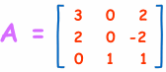
The Minor is calculated as follows:
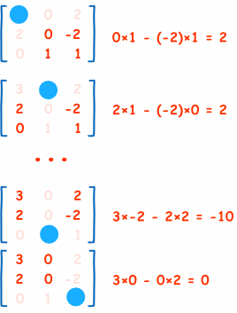
The calculation for the whole matrix is:
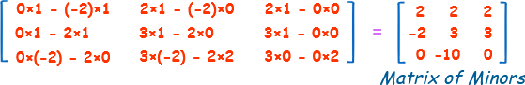

The Matrix of Cofactors is calculated by changing the sign of alternate cells, like this.
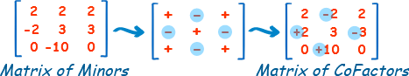

Transpose of a Matrix
The matrix obtained from a given matrix A by changing its rows into columns and columns into rows is called the transpose of A and is denoted by A1 or AT. The transpose of matrix A.

𝑎 𝑏 𝑐
𝑎₁ 𝑎₂

𝐴 = [ ¹ ¹ ¹] Then , 𝐴^{𝑇} = [𝑏₁ 𝑏₂]

𝑎₂ 𝑏₂ 𝑐₂
𝑐₁ 𝑐₂

For example, if matrix A is:
7 10 13

7 11 15

𝐴 = [11 14 17 ] then, 𝐴^{𝑇} = [10 14 18]
15 18 21 13 17 21
Hence, if A be of order m х n, then AT is of order n х m. It is evident that the transpose of the transpose of a matrix is the given matrix itself. i.e. [AT] T = A
If A = [aij]mхn, then,
AT= [aij]mхn where a1ji = ai

Note:

(A + B)T = AT + BT (AB)T = BT AT

Adjoint of a Matrix
If A = [aij]mхn be a square matrix, then the transpose of the matrix [aij]mхn whose elements are the Cofactors of the corresponding elements in determinant of A or |A| is called the Adjoint or Adjugate matrix of A and is denoted by adj A.
𝑎11 𝑎12 𝑎13
The determinant of the square matrix 𝐴 = [𝑎21 𝑎22 𝑎23] is
𝑎31 𝑎32 𝑎33
𝑎11 | 𝑎12 | 𝑎13
|𝐴| = |𝑎21 | 𝑎22 | 𝑎23|
𝑎31 | 𝑎32 | 𝑎33

𝐴11 𝐴12 𝐴13
The matrix formed by the Cofactor of elements in |A| is [𝐴₂₁ 𝐴₂₂ 𝐴₂₃];
𝐴31 𝐴32 𝐴33

The transpose of this is = adj A
1 1 3
−24 −8 −12

For example, the Adjoint of [ 1 3 −3] is [ 10 2 6 ]
−2 −4 −4 2 2 2
Where -24, 10, 2 are the Cofactors of 1, 1, 3 respectively and soon. Verify the above answer.

Reciprocal Matrix
The Adjoint of a square matrix A divided by the determinant of A is called the reciprocal matrix of A and is denoted by A-1 . Thus,
𝑨−𝟏 = 𝒂𝒅𝒋 𝑨
|𝑨|
A-1 exist only when A ≠ 0 (i.e. only when A is a non-singular matrix.

𝑎11

𝑎12

𝑎13
𝐴11
⎡ |𝐴|
₋₁ ⎢𝐴12
𝐴21
|𝐴|
𝐴22
𝐴31
|𝐴| ⎤
𝐴32⎥

Thus, if 𝐴 = [𝑎21 𝑎22 𝑎23] then 𝐴
𝑎31 𝑎32 𝑎33

cofactor of aij in |A|.
= ⎢ |𝐴|
⎢𝐴13 [ |𝐴|
|𝐴|
𝐴23
|𝐴|
|𝐴| ⎥
𝐴33⎥
|𝐴| ]
when Aij is the

For example, the reciprocal of the matrix 𝐴 = [
1 1 3
1 3 −3] is
−2 −4 −4

−24 −8
⎡ −8 −8
−12
−8 ⎤
3 1 3
2
⎤
⎡

10 2

−8 −8
⎢ 2 2
6 = −5 −1
−8 −4 4
2 ⎥ ⎢−1 −1
−3 ;
−4
−1⎥

[ −8 −8 −8 ] [ 4 4 4 ]

Verify the answer above.

An important property of the reciprocal matrix is that AA-1= I where I is an identity matrix or unit matrix of the same order as that of A.

Inverse of a Matrix
In algebra, if ax = y, then x = a-1y, where a-1 is called the inverse (or reciprocal) of a, such that a-1 = 1/a. In matrix algebra, division is not defined and the reciprocal of a matrix does not exist in algebraic sense. However, if for three given square matrices A, X and Y, AX = Y, then X=A-1Y, where A-1 is called the inverse of matrix A such that AA-1= I

Thus, we can say that for a given square matrix A of order n, if there exist another matrix square matrix B of the same order such that AB = I, where I is the unit matrix of order n, then B is called the inverse of A and is denoted by A-1

The reciprocal matrix of a given matrix A is also an inverse of A, for AA-1 = A-1A

A matrix inverse exist only if the matrix is square and non-singular i.e. the determinant is non-zero. Thus, not every square matrix has an inverse. However, if the inverse exists then it is unique, that is, for a given square, non-singular matrix there exist only one inverse matrix.

Non-square matrices do not have inverses. Not all square matrices have inverses. A square matrix, which has an inverse, is called invertible or nonsingular, and a square matrix without an inverse is called noninvertible or singular.

Consider the product of two 3 х 3 matrices

1 2 3
6 −2 −3
1 0 0

[1 3 3] [−1 1 0 ] = [0 1 0]

1 2 4
−1 0 1
0 0 1

If this product is represented by AB = I then A is called the inverse of B and B is called the inverse of A.

Notes
      - The inverse (or reciprocal) of the product of two matrices is same as the product of their inverse in the reverse order. i.e. [AB]-1 = B-1 A-1
      - If A has an inverse matrix, then (A-1)-1 = A

      - Reciprocating and transposing operations are commutative.

i.e. [A-1]T = [AT]-1
For a 2 х 2 matrices give by 𝐴 = [𝑎 𝑏] , the inverse can be found using this
𝑐 𝑑
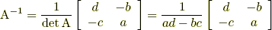
formula:

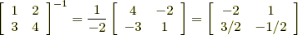
For example,

For any square matrix of order 3 and above, the following steps should be followed to compute the inverse of matrices.
Step 1: calculating the Matrix of Minors,
Step 2: then turn that into the Matrix of Cofactors, Step 3: then the Adjugate, and
Step 4: multiply that by 1/Determinant.

Other methods are also available but they are outside the scope of this course. Example: find the Inverse of A:

Step 1: Matrix of Minors

Step 2: Matrix of Cofactors

Step 3: Adjugate (also called Adjoint)

2 | 2 | 0
[−2 | 3 | 10]
2 | −3 | 0
Step 4: Multiply by 1/Determinant
Determinant = 3×2 + 0×(−2) + 2×2 = 10
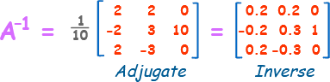
The notion of inverse of a matrix can be extended to solve system of linear equations.

Exercise: Find the inverse of the following matrices
 | 1 | 3 | 7
(a) | 𝐴 = [4 | 2 | 3]
 | 1 | 2 | 1
 | 1 | 2 | 3
(b) | 𝐴 = [0 | 4 | 5]
 | 1 | 0 | 6

3 2 −1
(c) 𝐴 = [1 6 3 ]
2 −6 0

Orthogonal Matrices
A square matrix A is said to be orthogonal, if its transpose AT produces unit matrix when multiplied by A. i.e. if AT. A = I, A is an orthogonal matrix. For example, [𝑐𝑜𝑠𝜃 −𝑠𝑖𝑛𝜃] is an orthogonal matrix because
𝑠𝑖𝑛𝜃 𝑐𝑜𝑠𝜃
[ 𝑐𝑜𝑠𝜃 𝑠𝑖𝑛𝜃 𝑐𝑜𝑠𝜃 −𝑠𝑖𝑛𝜃 1 0
−𝑠𝑖𝑛𝜃 𝑐𝑜𝑠𝜃] [𝑠𝑖𝑛𝜃 𝑐𝑜𝑠𝜃 ] = [0 1]
Similarly, [1 0] and 1 0 ] are also orthogonal.
[
0 1 0 −1
The value of the determinant of an orthogonal matrix A is either 1 or -1 because
AT.A= I. Therefore, |ATA|=|AT||A|=|A|2= |I|=1 which implies |A|=±1.

Class Exercises
- Find the values of x, y, z and t for which the following holds.
3 [𝑥 𝑦] = [ 𝑥 6 ]+[ 4 𝑥 + 𝑦]

𝑧 𝑡
−1 2𝑡
𝑧 + 𝑡 3

3 2 1
- Compute the adjoint and inverse of the matrix 𝐴 = [1 1 1 ] and verify
5 1 −1
if AA-1 - if AA-1 = I
- Show that the inverse of the matrix [𝑐𝑜𝑠𝛼 −𝑠𝑖𝑛𝛼] is [ 𝑐𝑜𝑠𝛼 𝑠𝑖𝑛𝛼]
𝑠𝑖𝑛𝛼 𝑐𝑜𝑠𝛼 −𝑠𝑖𝑛𝛼 𝑐𝑜𝑠𝛼
- Solve by matrix method the equation, x – y = 2, y – z = 1, x + y + z = 7.

